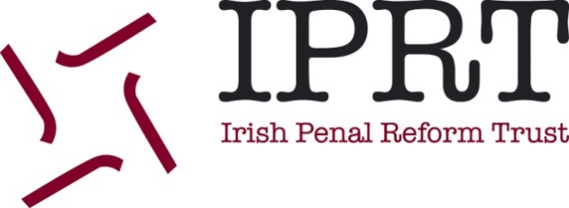

FEEDBACK & COMPLAINTS POLICY

Date of Adoption | 12th November 2014
Date of Review
Purpose
IPRT is committed to ensuring that all our communications and dealings with the general public and our supporters are of the highest possible standard. We are committed to listen and respond to the views of the general public and our supporters so that we can continue to improve. This policy is intended to ensure that complaints are dealt with properly and that all complaints or comments are taken seriously and addressed in a professional manner.
Principles
IPRT welcomes and actively seeks both positive and negative feedback. Therefore we aim to ensure that:
- It is as easy as possible to praise or make a complaint to IPRT.
- Any communication that clearly expresses dissatisfaction with our operations and calls for a response is treated as a complaint.
- We will treat complaints as serious no matter the correspondence method i.e. face-to-face, telephone, email, letter or any electronic mode of communication.
- We will deal with all complaints promptly, politely and with respect.
- We will respond to all complaints in accordance with the complaint either by providing further information or an apology if a mistake has been made.
- We will learn from complaints and apply all learning, we will also monitor them and report these to our Board.
Procedure
If you have feedback or a complaint – Step One

If you do have a complaint about any aspect of our work, you can contact the member of staff concerned directly or the IPRT office by email at communications@iprt.ie

You can also contact us in writing or by telephone at IPRT, MACRO Building, 1 Green Street, Dublin 7 and at +353 1 874 1400

In the first instance, your complaint will be dealt with by the Deputy Director.

Please give us as much information as possible and let us know how you would like us to respond to you, providing relevant contact details.

If you complain in person or over the phone, we will try to resolve the issue there and then. Similarly, if you complain by email or in writing we will always acknowledge your complaint within 5 working days, and do everything we can to resolve it within 14 working days. If this is not possible, we will explain why and provide a new deadline.

If you have feedback or a complaint – Step Two

If you do not feel your complaint has been adequately resolved we will refer your complaint to our Executive Director who will acknowledge your complaint within 5 working days, and do everything they can to resolve it within 14 working days. If this is not possible, she will explain why and provide a new deadline.

What if the complaint is not resolved?
If you are not happy with our response, you may get in touch again by writing to the Chairperson of the IPRT Board. The Chairperson will ensure that your appeal is considered at Board level and will respond within two weeks of this consideration by Board members. The decision of the Chairperson will be final.
You can contact the IPRT Chairperson at Michael O’Flaherty c/o IPRT, MACRO Building, 1 Green Street, Dublin 7 marking your correspondence private and confidential.

