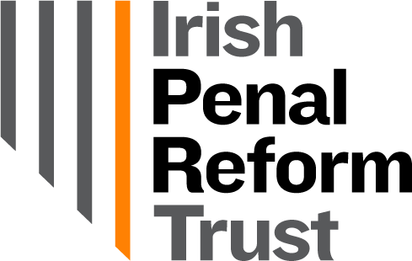

Code of Conduct
for Organisational Members of IPRT

Adopted by the Board on: | 18 May 2022
To be Reviewed on:

About IPRT
IPRT is a company limited by guarantee not having share capital and is also a registered independent charity. IPRT is committed to the values of equality, human rights and social justice.

Purpose
This Organisational Members’ Code of Conduct is intended to ensure IPRT continues to fulfil the highest standards of ethical and professional practice in all its work.
Organisational members of the Irish Penal Reform Trust affirm their commitment to this Code and acknowledge their agreement to be bound by it through their approval by the Board of IPRT as an organisational member.
Breach of this Code of Conduct may give rise to the revoking of organisational membership by the Board of IPRT.

Code of Conduct

- Each organisational member will abide in all respects by this Code of Conduct and all rules and regulations of the Irish Penal Reform Trust, including its Memorandum and Articles of Association.

- Each organisational member shall uphold the vision, mission and values of IPRT. New organisational members are subject to Board approval.

- Each organisational member has a duty to avoid any action that may damage the reputation of IPRT.

- Organisational members shall treat IPRT Board, staff and volunteers, and other IPRT members, with fairness, equality, dignity and respect. Organisational members shall treat all speakers at IPRT events with such fairness, equality, dignity and respect.

- Organisational members do not have the right to speak on behalf of IPRT, or hold themselves out as speaking on behalf of IPRT, except with the express permission of IPRT’s Executive Director and/or Chairperson.

- IPRT welcomes a diversity of opinions and encourages debate on the topics it engages with. Organisational members commit to abiding by the principle that, where there is a difference of opinion between the organisational member and IPRT, the IPRT position should be acknowledged in any public discussion.

- The Governance and Administration Officer will monitor this area and escalate any concerns to the Executive Director, who will inform the Board if the matter cannot be resolved informally. This code of conduct will be communicated to the team, who will report any concerns they have to the Membership and Governance Officer.

- If IPRT suspects or finds that an organisational member has breached this Code of Conduct, the matter will initially attempt to resolve the matter informally. Where this fails, or the Board decides that an informal approach is inappropriate, the IPRT Board may decide to start a formal process for removing the organisation’s membership of IPRT.

- Where a decision is made to strip an organisation of membership of IPRT, the member may request that the matter is referred to the IPRT Chair and Board using the appeals stage of the following process: Feedback & Complaints.

Signed:

Date:

